24.2.21
T: Can I explain the three states of matter?
Solid | Liquid | Gas
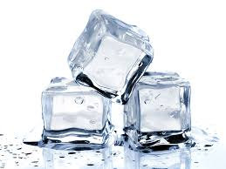  hard, firm, cold, wet, frozen, clear, transparent | 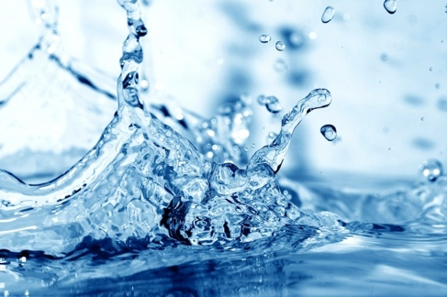  wet, warm, cold, hot, clear, transparent, still, wavy | 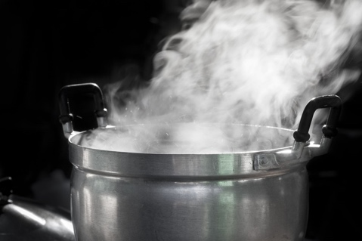  Wet, cloudy, hot, warm, thick, white
Write 3 examples of solids:  1.  2.  3. | Write 3 examples of liquids:  1.  2.  3. | Write 3 examples of gases:  1.  2.  3.

Use what you have learnt on the BBC bitesize website and in the PowerPoint to write your descriptions. If you get stuck, you can always look back at the information you have been given.

- Describe what happens when a solid turns into a liquid.

- Describe what happens when a liquid turns into a solid.

- Describe what happens when a liquid turns into a gas.

- Describe what happens when a gas turns into a liquid.

